Minutes of the Meeting of the Parish Council on 13th December 2021 at 7.30pm
At Hailey Village Hall

Present: Cllrs: G Knaggs (in the chair), A. Smith, M. Drew, A. Gibson, District Cllr C. Dingwall, District Cllr. G. Hill & County Cllr L. Walker. Parish Clerk: T. Cameron, 8 members of public

1. To receive apologies for absence:
Apologies were received from Cllr G. Doland

2. To receive Declarations of Interest: none were received.

3. Contributions from members of the public: Member of the public questioned why there was no longer contributions from the public at the end of the agenda. Was advised that it was not a conscious decision.
A member of the public spoke with regards to the New Village Hall. They advised that when the initial discussion was made that there was talk about it being funded by CIL (community infrastructure levy). They were advised that WODC has not adopted CIL and at the moment that there is no definitive source of funding. They also brought up the issue that there could be problems with access. A member of the Village Hall Committee also spoke to advise that this has been an ongoing project

4. To receive the Minutes of the Parish Council Meeting dated 8th November 2021 and Extraordinary Meetings of the Parish Council dated 1st December 2021:
These were agreed and signed as a true record.

5. Matters arising from the minutes: None.

6. To receive update reports from West Oxfordshire District Council and Cllr Liam Walker, Oxfordshire County Council:
Cllr G Hill – The pop-up vaccine hub in Witney has been working well.
Cllr C Dingwall – There is extra money available from the government for vulnerable household for food, water and energy bills. They just need to contact Citizens Advice. Also, bins will be collected as normal over the Christmas period even on the bank holiday.
Cllr L Walker – OCC are running a program for 20mph speed limit. If Hailey would like it we need to let Cllr Walker know.

7. Planning:

21/03561/FUL Farm Buildings southeast of Crawley Hill Farm, Foxburrow Lane, Crawley
The application form is factually incorrect in that it certifies that the land edged red on the site location plan, overleaf, is, in the applicant's ownership but this is not the case. The entire length of the access track from Foxburrow Lane up to the barn proposed to be converted is not owned by the applicant and there is no right of access to a dwelling or storage of refuse bins. If this is the case, then the application must fail as there is no access to the property.
If the access to the farm building IS owned by the applicant, then I fell that we must object. The building in question is not suitable for 'conversion' and does not meet any criteria within policy H2.
It is not existing housing so cannot be considered under policy H6 and it also does not meet any criteria within policy E3

POLICY E3: Re-use of non-residential buildings
The Council supports the re-use of traditional buildings for employment, tourism and community uses to support the rural economy where the following criteria are met:
• the existing form and design of the building(s) positively contribute to the character of the area; and
• the building(s) are capable of conversion to the proposed use without necessitating alteration(s) or extension(s) which would harm the form of the original building and without removing features of historic, architectural or nature conservation interest; and
• the building(s) are suitably located for the scale and type of the proposed use, having regard to the level of accessibility to settlements, facilities and services and impact on the character and amenity of the area. The re-use of non-traditional buildings, including modern farm buildings, for employment, tourism and community uses will be supported within or adjoining Service Centres or Villages, or where it forms part of an agricultural holding, and the proposal is part of a farm diversification scheme under Policy E2 or where re-use would address a specific local need which cannot be met in an alternative way. This is provided that the following criteria are met:
• the general character and form of the building(s) are not harmful to the surroundings; and
• the scale and type of use is suitable to its location and will not result in excessive alteration(s) or extension(s) to the host building
I feel we should object.
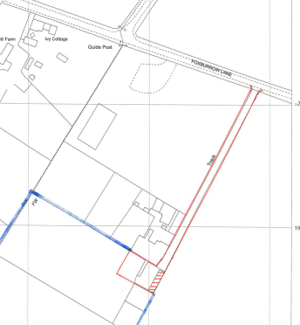
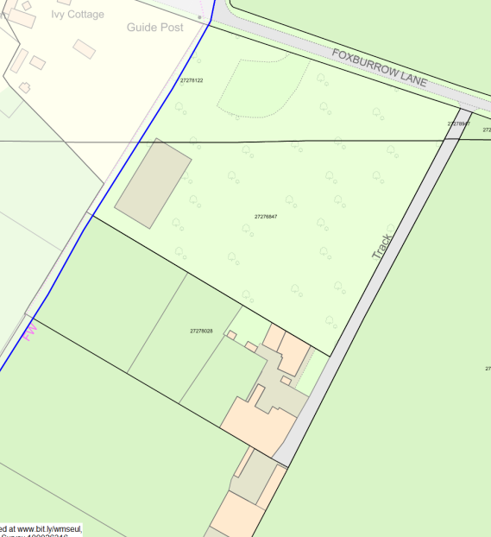
- Planning applications received:
Ref no: | Address | Proposal | PC Decision
21/03561/FUL | Farm Buildings southeast of Crawley Hill Farm, Foxburrow Lane, Crawley | Conversion of a barn to a dwelling, works to include the addition of a pitched roof to provide first floor living space | PC to Object
21/03735/HHD | Aspley House, Wood Lane, Hailey | Demolition of garage and construction of two storey extension | PC – No objection

- Decisions outstanding:
Ref no: | Address | Proposal | PC Decision
14/01671/OUT | Land northwest of Woodstock Rd, Witney | Outline application for the erection of up to 200 residential dwellings and associated vehicular, pedestrian and cycle access, related highway works, drainage and landscape works including provision of public open space (Amended) | Object  WODC -Under Consideration
21/02320/FUL | Land south of Giernalls Rd, Hailey | Erection of 22 dwellings with associated access, landscaping, open space and infrastructure. | Object (to spur)  WODC-Under Consideration
19/03317/FUL  amended | Land west of Hailey Rd, Witney | Erection of 106 (reduced from 110) residential dwellings, changes to layout to increase area of public open space, increase in percentage of affordable housing | Object  WODC-Under Consideration

- Decisions made:
21/03302/FUL | Land adjacent to Clovelly Cottage, Whiteoak Green | Construction of a detached garage for storage not in connection with Clovelly Cottage (part retrospective) | WODC - Refused
21/03323/HHD | 1 Yorke Cottages, New Yatt Road, Witney | Single storey front and rear extensions. Form new vehicular access. Replace existing garage. | PC - No objection  WODC - Approved
21/03376/HHD | 21 Giernalls Rd, Hailey | Single storey rear extension | PC - No objection  WODC - Approved

8. Platinum Jubilee:
- Plan is still being finalised but…
- Thursday nationwide events – Trooping the Colour and Lighting of Platinum Beacons
- In Hailey – we have our beacon from the Diamond Jubilee (2012) which we will light [at location tbc]
- Friday nationwide events – Service of Thanksgiving at St Paul’s Cathedral
- In Hailey – Party at the Lamb & Flag Pub [band tbc] & DJ (confirmed)
- Saturday nationwide events – Epsom Derby and Live Concert at the Palace
- In Hailey – No plans
- Sunday nationwide events – Big Jubilee Lunch
- In Hailey – Big Jubilee Lunch at the Recreation Ground and Village Hall

9. Village Hall:
(a) Village Hall Management Committee - The work to the flat roof of the hall has now been completed by Woodstock Roofing. The total cost was just over £15,000 including VAT, which is being paid by the VHMC. Other incidental work associated with the roof replacement has been carried out by Graham Franklin. Measures to ensure Covid security for users of the hall continue, particularly sanitising and mask wearing. Two fund raising events have taken place - a bingo evening and the Annual Band Concert, both successful although with restricted attendance.
The PC is asked to note this report.

10. Neighbourhood Policing Report:
- This month’s alerts have included warning about increase in theft of number plates, an updated Neighbourhood Watch newsletter, warning about scams in general (postcode lottery-related scams in particular), online fraudsters with advice provided for avoiding scams, a warning about having effective online passwords in place
- The VAS on Delly Hill is currently not working. We have made contact with Wendy at Swarco and we are arranging an engineer visit (under our warranty)

11. Amenities:
(a) Playground:
- Routine recorded inspection of play equipment – carried out on 22 October. There is nothing of significance to report.
- Update on maintenance – specialist contractor RPM has carried out the requested work. Work proposed for volunteers – bark topping up and resurfacing of BMX track – has been delayed as principal volunteer is in self isolation with Covid. To be followed up.
- Update on weeding/cleaning playground
The advert in the October Hailey Herald for paid worker has produced no response yet.

(b) Sale of Wood Green
No update.

(c) Update on installation of defibrillator at New Yatt
- To receive quotes for an electrician for final installation work
No update.

12. Highways and Traffic:
(a) Burford Experimental Traffic Regulation Order update

WiVTAG has submitted its Final Report to OCC. Here’s the conclusion:
WiVTAG contends that the Burford ETRO could have been avoided if, by logical application of existing County LTP strategy, the HGV ban proposed by BTC had been identified as not meeting the full intentions of that strategy. The minor town and parish councils surrounding Burford have always accepted that essential farm and HGV traffic (delivering or collecting locally) is a necessity in the rural environment; we are confident that they will continue to do so. Whatever the scenario, it is apparent that HGV restrictions in local towns, villages or bridges simply divert the problem; they are not a solution. Some mediation may identify a compromise, but no such way forward can be activated without the immediate revocation of the Burford A361 ETRO. WiVTAG’s conclusion is that the Burford scheme has failed. It has not satisfied the approved performance criteria, nor has it made allowance for the adverse impacts on surrounding communities and businesses. We urge OCC to revoke the Burford ETRO.
Gloucestershire CC has formally objected to any extension of the Burford ETRO.

(b) Update on Flooding Working Group
- Generally good work has continued in/around Delly End – effective ditches established on Whitings Lane, OCC contractors have been present as recently as a fortnight ago at the Delly End crossroads, any gullies full of detritus over the pipe level should be reported via fixmystreet
- It is very unlikely to see any works on the LEDA Properties land proposed for solar farm until a decision is made
- Can the clerk confirm that we wrote to LEDA Properties requesting they clear the ditch in Poffley End please? Randolph is very keen that this is completed asap, especially in this rainy season – A letter was sent to LEDA on 21st November 2021

(c) Update on Gigaclear
- The current plan is for the main access cabinet to go live on Friday 17/12/21
- First residents will be able to start the order process soon after
- Road works will slow down considerably from the end of this week until in the new year
- The Network Build Care team are available throughout the Christmas period if there are any residents’ queries

13. Environment
(a) Burial Grounds
- One Burial took place during November
- Following our agreement to create a Queens Forest Canopy, Cllr Drew is going to collect the the 8 trees, with plans to plant them over the winter.

(b) Footpaths
- To note recommendation by OCC to upgrade to a Restricted Byway from Bridewell Cottages to North Leigh Lane in the Parishes of North Leigh and Hailey.

(c) Grass cutting
Cutting of the Burial Ground hedges is not on Mr McCracken contract, despite
doing it in previous years – Parish Council have agreed to pay up to £100 for the task of hedge cutting.
Cllr Drew proposed with Council approval asking Roger Cantwell to complete the task. Resolved

(d) Trees
- To consider location of 30 trees from Woodland Trust
- As requested, JAG Timber – Hugh, is quoting a price for raising the canopy of two Lime trees in
the recreation field. No further info

(e) Update on repair of sign at Delly Pool
Cllr Drew has painted the upright post on Delly Pool and is awaiting the two fingerposts from Beeline joinery who quoted a price of £300 for two primed finger posts and Mark £30.00 for fixing them.

(f) Verge at Delly Pool
Following concerns re overgrown shrubs, and the Chairman’s comment that it is OCC land and therefore
their responsibility, Cllr Drew suggests that action is taken to remove the fallen willow tree referred to, and a pair of secateurs used to clear the sign referred to but that other shrubs are not overgrown at present.

(g) To note previous clerk has signed a Statement of Truth to aid with application to register Delly Green
with the land registry

14. Allotments (including Allotments for Labouring Poor Charity) ALP:
(a) Update on request to purchase strip of land along Priest Hill Lane adjoining Giernalls Triangle by Leda Properties (
The valuer has quoted £1,500 plus VAT plus expenses to value the land and £750 plus VAT plus expenses to value the easement. Although we asked for this valuation in August the valuer advises they are busy and will not complete the work until the new year.
Recommend we accept the valuation cost estimate but not the easement. PC resolved to accept both quotes.

(b) The painting of the five-bar gate to the allotments is to be followed up in the Spring.

HPC (Hemplands):
(a) Update on Hemplands allotments:
- Water supply – Leak into inspection chamber reported previously to the PC is being pursued with Thames Water. The water remains turned off.
- Improvements to allotments – paths, raised beds, etc. – Grants for this work will be pursued after Christmas
- Car Park – responsibility for maintenance - our former Clerk discovered reference to ownership of the land belonging to Witney RDC in minutes dating back to 1968. The minute book is currently with Welch & Stammers. This will be followed up on return of the minute book.
- To consider request for shed and greenhouse on plot 8 – Parish Council has agreed to shed and Greenhouse.
- To consider request to cut down dead plum tree on plot 8 – Parish Council has agreed that the Plum Tree to be removed.
- To note land registration of Hemplands allotments with the Land Registry is complete
The PC is asked to note this report.

15. Finances and Administration:

(a) Payments received:

Peter Smith Funeral Directors | Burial fees | £694.00

(b) Accounts for authorisation and payment:

Lisa Wilkinson | Clerk’s November net salary | £535.14
 | Expenses/Allowance | £26.00
 | Total: | £561.14
Nest | Clerk’s pension (Direct debit) | £40.18
Hailey Village Hall | Room hire (November) | 45.00
Netwise UK | Domain renewal | £24.00
B&Q/Relics of Witney (Repay M. Drew) | Repair Delly Pool signpost | £772.11
Charlbury Garden Centre/ Nicholson’s/Drainage Superstore  (Repay M. Drew) | Trees/materials for Burial Ground | £490.35
Ubico | Emptying bin at playground (Oct 21 – Mar 22) | £211.10
Welch & Stammers solicitors | Registration of Hemplands allotments | £300.00
Information Commissioner’s Office | Data Protection renewal | £35.00
These were authorised by Cllrs Knaggs & Gibson

(c) Hailey Parish Council bank balances:

To 30th November 2021
Unity Trust Current Account | £11,338.79
Unity Trust Deposit account | £33,697.77
COIF Public Sector Deposit Fund | £35,000.00
Allotments for Labouring Poor | £5,215.89
Allotments for Labouring Poor COIF deposit account | £32,747.47

16. Correspondence received: None.

17. Other Items to Note:
Randolph has secured an offer for Ron Godfrey (16 Hailey Road) to paint the gate (£50, including materials) that Randolph donated to the parish some years ago. It was proposed that we take him up on this offer, to keep the gate in a well-maintained state - Resolved

18. New Village Hall Project: The public shall not be able to make comment on this point. Cllr Drew made a comment that he believes that the new overall development contained in the brief is too large to the population that it is aimed at and the site that is envisaged. He also feels that it is sited in the wrong location. He also feels that the people of the village have not been properly consulted. Cllr Knagg proposed that discussions are stopped owing to time constraints and that the Parish Council make a date for a single-issue meeting which will be 11th & 17th January and also the date of the public meeting which will be 6th February at 2pm.

19. Dates of Parish Council meetings 2021-22:
Monday 10th January 2022
Monday 14th February 2022
Monday 14th March 2022*
Monday 11th April 2022
(* denotes Joan Smith Educational Charity meetings)

Meeting closed: 9pm

Signed ……………………………………………………………………

Date ……………………………………….

